It is provided by following condition:

if ($contest->validate() && Model::validateMultiple($prizes)) { ...}

Go to the /index. php?r=contest/update page and you will see this form:

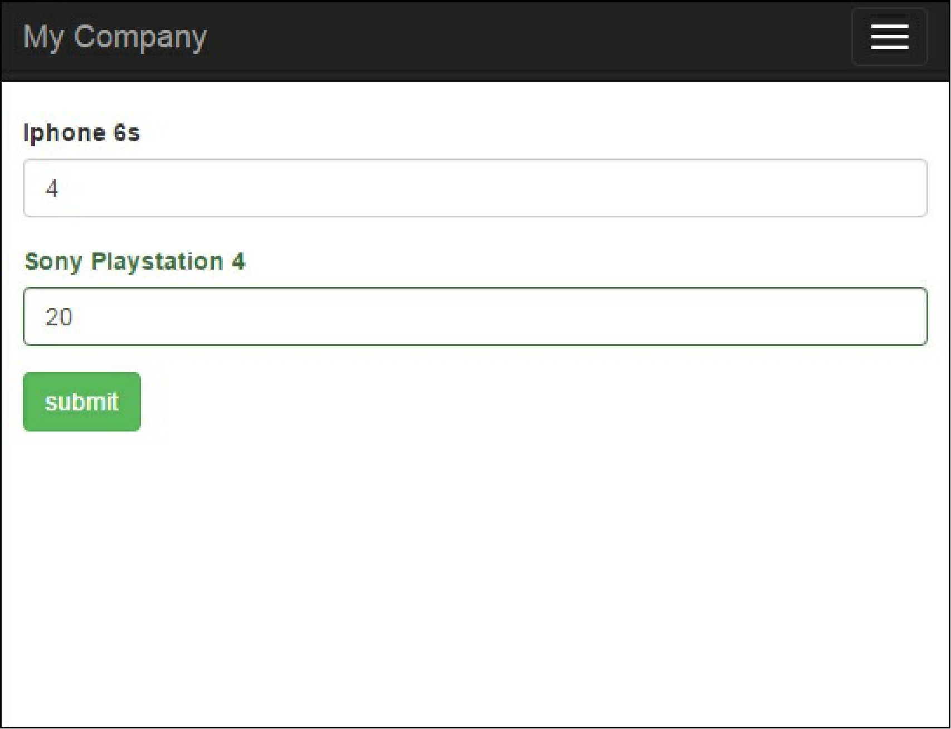

In the @app/views/contest/update. php for each prize, we render a name and an input with an amount. We must add an index to each input name so that Model: : loadMultiple() may identify which model to fill with which values.

In conclusion, this approach is used for collecting tabular input data when you process all your attributes from a view form and populate parent and related models from the form.

See also

For further information, refer to the following URL:

[http://www.yiiframework.com/doc-2.0/gurde-input-tabular-input.html#co]lecting-tabular-input](http://www.yiiframework.com/doc-2.0/guide-input-tabular-input.html%23collecting-tabular-input)